|  |  |  |  |  |  |  |  |  |  |  |
| --- | --- | --- | --- | --- | --- | --- | --- | --- | --- | --- |
|  |  |  | **1.** |  |  |  |  |  |  |  |
|  |  |  |  |  | **2.** |  |  |  |  |  |  |  |  |
|  |  | **3.** |  |  |  |  |  |  |  |  |  |  |  |
|  |  |  | **4.** |  |  |  |  |  |  |  |  |  |  |
|  |  |  | **5.** |  |  |  |  |  |  |  |  |  |  |
|  |  |  |  | **6.** |  |  |  |  |  |  |  |  |  |
|  |  |  | **7.** |  |  |  |  |  |  |  |  |  |  |
|  |  |  |  |  |  |  | - |  |  |  |  |  |  |
|  | **8.** |  |  |  |  |  |  |  |  |  |  |  |  |
|  |  |  |  |  |  |  | - |  |  |  |  |  |  |
|  |  |  |  |  |  | **9.** |  |  |  |  |  |  |  |
| **10**. |  |  |  |  |  |  |  |  |  |  |  |  |  |
|  |  | **11.** |  |  |  |  |  |  |  |  |  |  |  |
|  |  |  |  | **12**. |  |  |  |  |  |  |  |  |  |
|  |  | **13.** |  |  |  |  |  |  |  |  |  |  |  |
|  |  |  | **14.** |  |  |  |  |  |  |  |  |  |  |

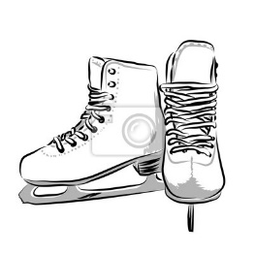

**9.**

**8.**

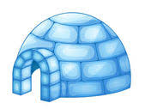

**4.**

**2.**

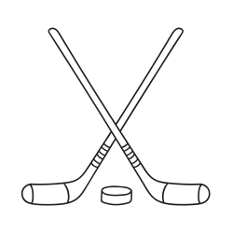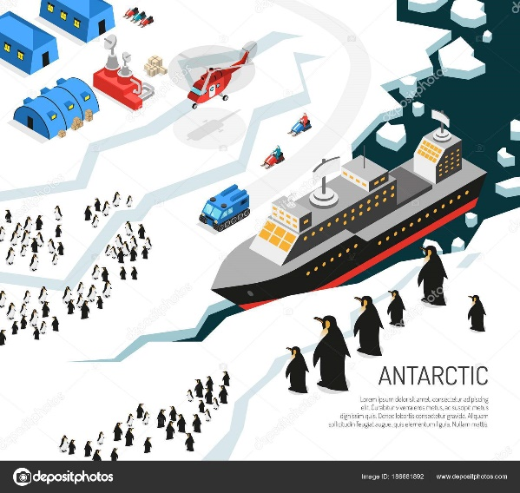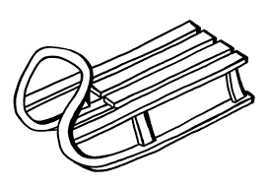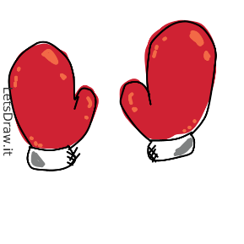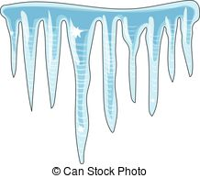

**11.**

**10.**

**7.**

**13.**

**14.**

**12.**

**6.**

**3.**

**1.**

**5.**